**Math Viva Final**

**Chapter 5**

**Multiple Integration**

**Multiple Integration:** The integrals of functions of more than one variable are known as multiple integrals (and are evaluated by a process involving iterated integrals).

**Partial Integration:** The process in which the integration is performed with respect to one variable treating the other variable(s) as constant is called partial integration.

**Iterated Integral:** A definite integral which is evaluated stage by stage using partial integration is called an iterated (successive or repeated) integral.

**Double Integrals:** The double integral may be defined geometrically in much the same way as the definite Riemann integral.

**Double Integrals over the rectangular region:**

**If *R* is the region defined by $R=\{(x,y)\left|a≤x≤b,c≤y≤d\}\right.$, then**

$$\iint_{R}{f(x,y)dA=\int_{a}^{b}{\int_{c}^{d}{f(x,y)dydx=}}\int_{c}^{d}{\int_{a}^{b}{f(x,y)dxdy,\text{where}s=f(x,y).}}}$$

**Double Integrals over the non-rectangular region:**

**(a) If *R* is the region defined by $R=\{(x,y)\left|a≤x≤b,f_{1}(x)≤y≤f_{2}(x)\}\right.$, then**

$$\iint_{R}{f(x,y)dA=\int_{a}^{b}{\int_{f_{1}(x)}^{f_{2}(x)}{f(x,y)dydx}}.}$$

1. **If *R* is the region defined by $R=\{(x,y)\left|c≤y≤d,g_{1}(y)≤x≤g_{2}(y)\}\right.$, then**

$$\iint_{R}{f(x,y)dA=\int_{c}^{d}{\int_{g_{1}(y)}^{g_{2}(y)}{f(x,y)dxdy}}.}$$

**Application of Double Integrals:**

**Area**: Plane area of a closed bounded region *R* is $A=\iint_{R}{dA}.$

**Example:** Using double integrals, find the finite area bounded by the following curves $y=x^{2 }\text{and }y=x+6.$

**Solution: $A=\iint_{R}{1}dA$**

$=\int_{x=-2}^{x=3}{\int_{y=x^{2}}^{y=x+6}{1dydx}}$

$=\int_{x=-2}^{x=3}{{[y]}_{x^{2}}^{x+6}}dx$

= $\int_{x=-2}^{x=3}{\left[x+6-x^{2}\right]dx}$

$={\left[\frac{x^{2}}{2}+6x-\frac{x^{3}}{3}\right]}_{-2}^{3}$

$=\frac{125}{6}.$

**Mass and center of mass**

**The co-ordinates $\left(\overline{x},\overline{y}\right)$ of the center of mass of a lamina occupying the region *D* and having density function $ρ\left(x,y\right)$ are**

$$\overline{x}=\frac{1}{m}\iint_{D}{xρ\left(x,y\right)}dA$$

$$\overline{y}=\frac{1}{m}\iint_{D}{yρ\left(x,y\right)}dA$$

**Where the mass $m$ is given by**

$m=$ $\iint_{D}{ρ\left(x,y\right)}dA$

**Example:** Find the mass and center of mass of the lamina that occupies

the region *D* and has the given density function $ρ$. Where

$D=\left\{\left(x,y\right)|0≤x≤1, 0≤y≤2\right\}$ and $ρ\left(x,y\right)=x+y.$

Solution: $m=\int_{0}^{2}{\int_{0}^{1}{\left(x+y\right)dx dy}}$

$=\int_{0}^{2}{{\left.\left(\frac{x^{2}}{2}+xy\right)\right|}_{0}^{1}dy}$

$=\int_{0}^{2}{\left(\frac{1}{2}+y\right)dy}$

$={\left.\left(\frac{1}{2}y+\frac{y^{2}}{2}\right)\right|}_{0}^{2}$

$=3$

$$\overline{x}=\frac{1}{m}\iint_{D}{xρ\left(x,y\right)}dA$$

$\overline{x}=\frac{1}{3}\int_{0}^{2}{\int_{0}^{1}{x\left(x+y\right)dx dy}}$

$=\frac{1}{3}\int_{0}^{2}{\int_{0}^{1}{\left(x^{2}+xy\right)dx dy}}$

**= $\frac{1}{3}{\int_{0}^{2}{\left.\left(\frac{x^{3}}{3}+\frac{x^{2}}{2}y\right)\right|}}_{0}^{1}dy$**

$=\frac{1}{3}\int_{0}^{2}{\left(\frac{1}{3}+\frac{1}{2}y\right)dy}$

$=\frac{1}{3}{\left.\left(\frac{1}{3}y+\frac{1}{2}\frac{{ y}^{2}}{2}\right)\right|}_{0}^{2}$

$=\frac{5}{9}$

***`***

**Double Integration in polar co-ordinate**

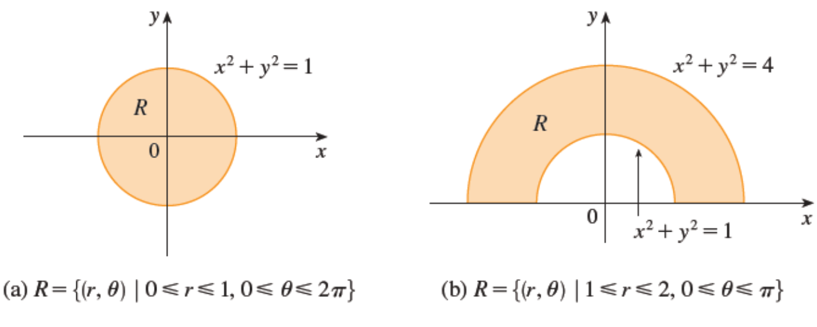

The polar coordinates $(r,θ)$ of a point are related to the rectangular

coordinates $(x,y)$ by the equations

$r^{2}=x^{2}+y^{2}$

$$x=r\cos{θ}$$

$$y=r\sin{θ}$$

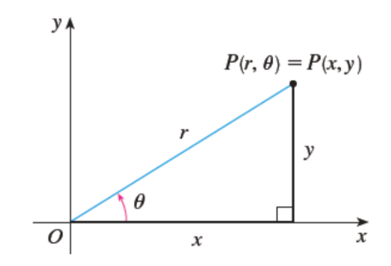

**Change to Polar Coordinates in a Double Integral**

f $f$ is continuous in a polar rectangle $R$ given by $a≤r≤b$, $α≤θ≤β$

Then

$$\iint_{R}{f\left(x,y\right)dA}=\int_{α}^{β}{\int_{a}^{b}{f(r\cos{θ, rsin θ)r dr dθ}}}$$

**Example**: Evaluate $\iint_{R}{e^{-(x^{2}+y^{2})}dA}$ where $R$ is the annulus

$x^{2}+y^{2}≥1$, $x^{2}+y^{2}≤4.$

Solution: $\iint_{R}{e^{-(x^{2}+y^{2})}dA}$

$=\int_{θ=0}^{θ=2π}{\int_{r=1}^{r=2}{e^{-r^{2}}r dr dθ}}$ $=-\int_{0}^{2π}{{(e}^{-4}-e^{-1}) dθ}$ $=$ ${2π(e}^{-1}-e^{-4})$

Chapter 6

Ordinary Differential Equation

**DE:** A differential equation (DE) is an equation that involves differentials or derivatives.

* An equation involving a function of one independent variable and its (ordinary) derivatives is called an ordinary differential equation (ODE).

For example, the equation,

$\frac{ⅆy}{ⅆx}+2y=5$ and $\frac{ⅆ^{2}y}{ⅆϰ^{2}}+y\frac{ⅆy}{ⅆx}+y=ⅇ^{x}sinx$

are ordinary differential equation as it contains only ordinary derivatives.

**Initial Value Problem (IVP)**

If a differential equation is required to satisfy conditions on the dependent variable and its derivatives specified at one value of the independent variable, these conditions are called initial conditions and the problem is called initial value problem (IVP).

**Example:** A stone is dropped from the top of a tower of height *h* under gravity can be expressed as

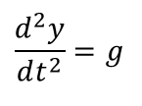 (neglecting friction)

with initial conditions when $t=0, y=h,\frac{dy}{dt}=0$

**Separation of Variables**

If it is possible to rearrange the terms of the DE in two groups each containing only one variable, the equation is said to be separable. A separable equation is of the form

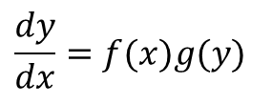

**Example 6.1:** Solve the following differential equation

**Solution:** The equation is separable and can be written as 

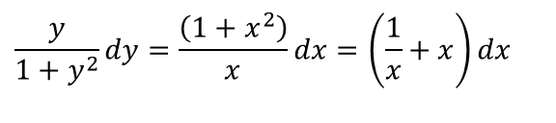

Chapter 7

The general *n*th order linear differential equations with constant coefficients is  
  
where  are constants.

be wriIn terms of differential operator $D≡\frac{d}{dx}$, it can tten as



or, in symbolic form, as $L\left(D\right)y=f(x)$

Where  is a polynomial in *D* of degree *n*. The equation is said to be homogeneous when $f(x) = 0$ and to be non-homogeneous when $f(x)≠0$**.**

We shall now concentrate on the solution of second order LDEs. The general form of the equation is



where $a_{0}, a_{1}, a_{2}$ are constants.

A trial solution $y=e^{mx}$ leads to the auxiliary equation (AE)



Suppose the roots of the auxiliary equation are $m_{1} and$ $m_{2}$.

The general solution, depending on the nature of the roots, may be expressed in any one of the following forms:

1. If $m_{1}≠m_{2}$ and both real, the solution is



1. If $m_{1}=m_{2}=α$ (say), the two solutions are not independent and becomes



(c) If $m_{1} and$ $m_{2}$ are complex, say $α±iβ$, the corresponding general solution is



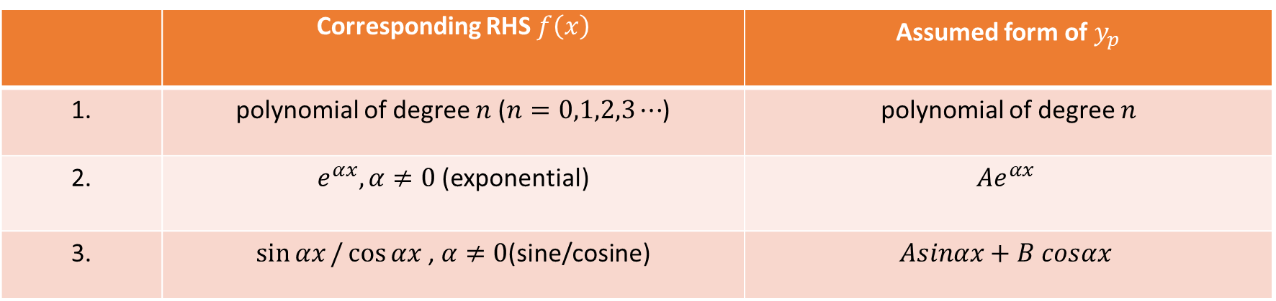

Yc (complementary function): the general solution of the auxiliary equation of linear differential equation. F(x) = 0

Yp (particular integral) f(x)=/ 0